
Day-3 SQL Challenge
Day-3 Challenge:
Retrieve the top 5 weeks with the highest patient refusals across all services, showing week, service, patients_refused, and patients_request. Sort by patients_refused in descending order.
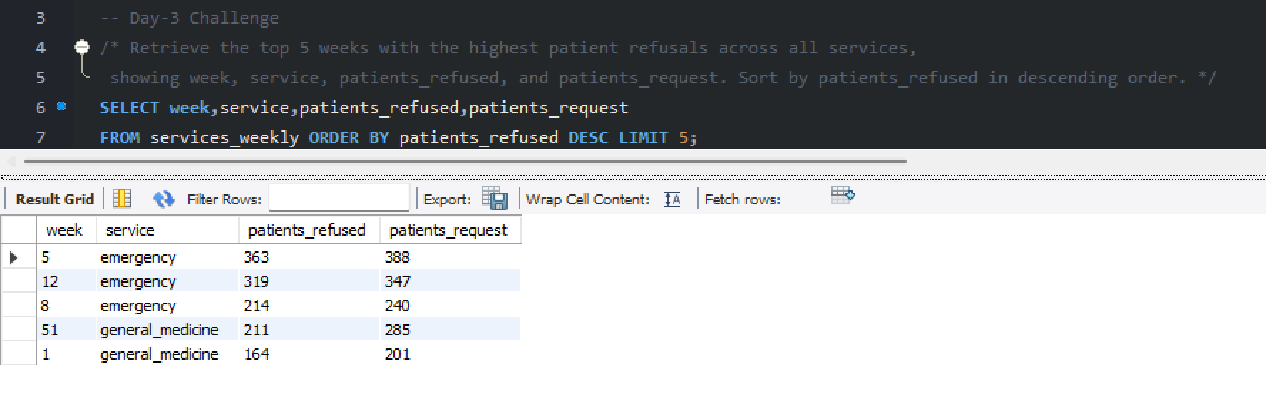

Practice Questions:
1. List all patients sorted by age in descending order.
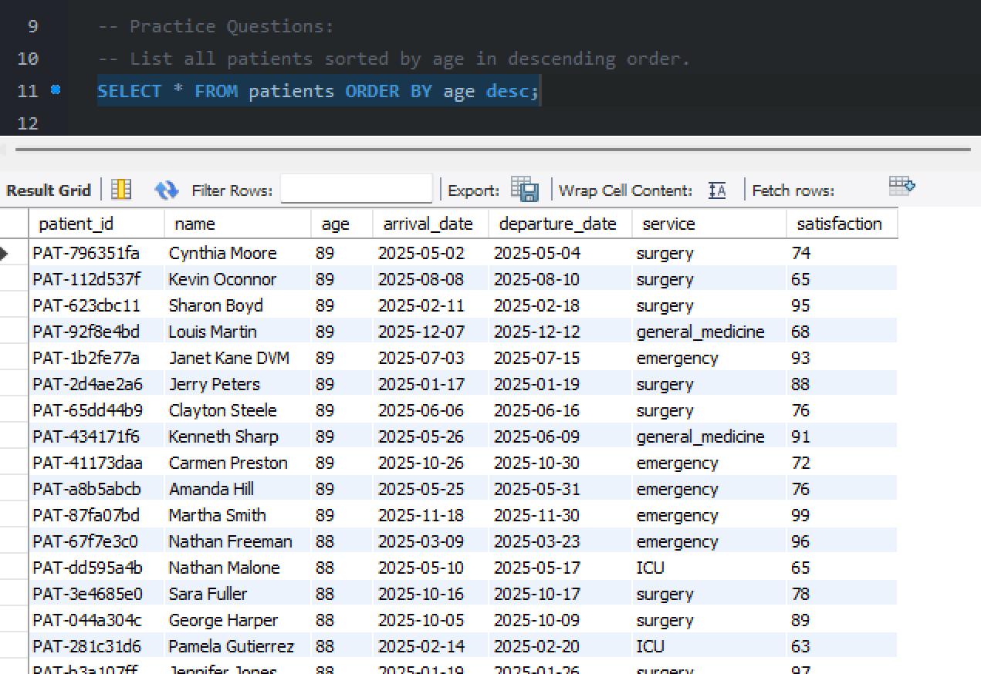

2. Show all services_weekly data sorted by week number ascending and patients_request descending.
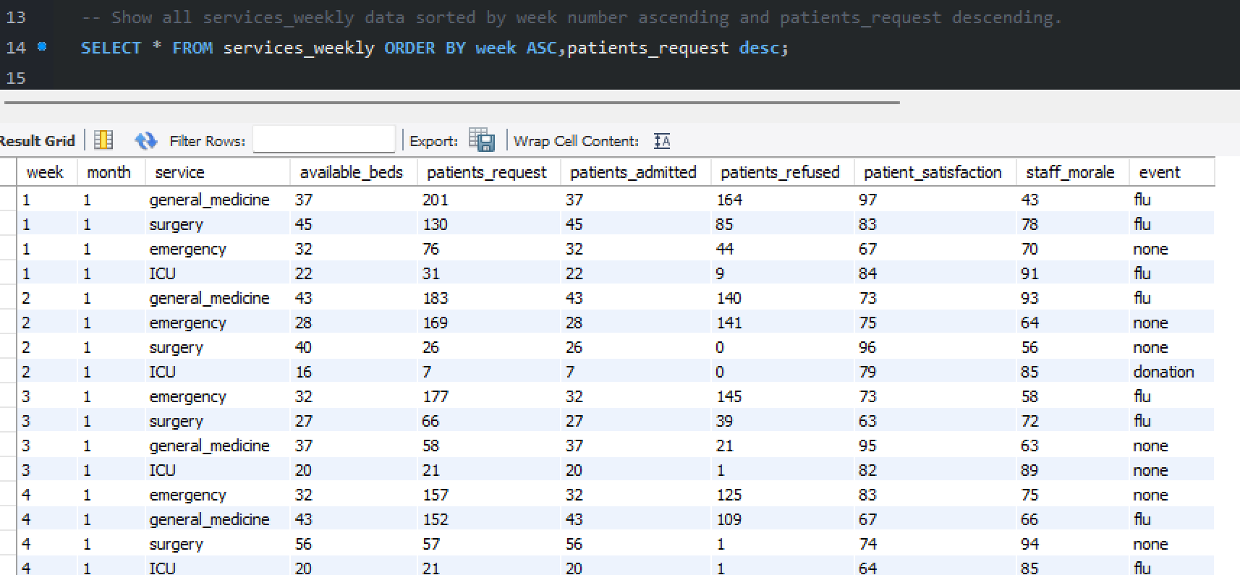

3. Display staff members sorted alphabetically by their names.
